**Back to the 19th Century...A Series of Articles on the Hollimans and Related Families of Fayette County, Alabama**

*By 1836, several sons of****James Grantson Holliman****(1750 - 1836) and other associated families had migrated to Fayette County, Alabama from Lancaster, South Carolina.****Cornelius****(1792 - 1862),****Charles****(1795 - 1850) and****Warren Holliman****(1801 - 1876) were part of the westward movement of the American nation and my family in the 19th Century.*

*Warren would later move on to Arkansas and father many Holliman descendants in that part of the United States.  Cornelius, Charles and many of their descendants remained in Fayette County and adjoining counties to this day.  Many others went to Mississippi, Louisiana and Texas.*

***An Excursion into History....***

*On* *April 9, 2011, Glenda Norris, a descendant of James Grantson and Cornelius Holliman families, led fifteen of her distant cousins through the cemeteries of her many great grandparents to share their stories.  She would be the first to tell you that she stands on the shoulders of her grandfather,****Cecil Rhodes Holliman****, and his son, her uncle,****Dr. Rhodes Holliman****.  The research about to be shared comes from their hands, also of the late****Walt Holliman****, a descendant of James Grantson and Charles Holliman, his son.*

Gathering for the tour near the Indian burial ground grave site of**Charles Daniel Lucas, Sr**. on am unseasonably hot sunny April day (92f) in the Deep South are some of the cousins. More photos of everyone will be shown later but from left to right are: Jeanette Holiman Stewart (Austin, Texas), Glenn Holliman (Newport, Pennsylvania), Lenwood Holliman (Gordo, Alabama), James Franklin Holliman (Sulligent, Alabama), Bishop Holliman (in cap from Avilla, Indiana), Vonceil Laura Duckworth (Reform, Alabama), Wally and Tommie Holliman (Irondale, Alabama), Faye Gardner (Kennedy, Alabama), Bill Holliman (Horn Lake, Mississippi), Jean Holliman (Irondale, Alabama), Joey Holliman (Florence, Alabama) and Tyler Duckworth (Reform, Alabama and at age 15, the youngest on the trip). Obscured is Robert Holliman and taking the photograph is Norman Holliman (both brothers from Marysville, Tennessee).

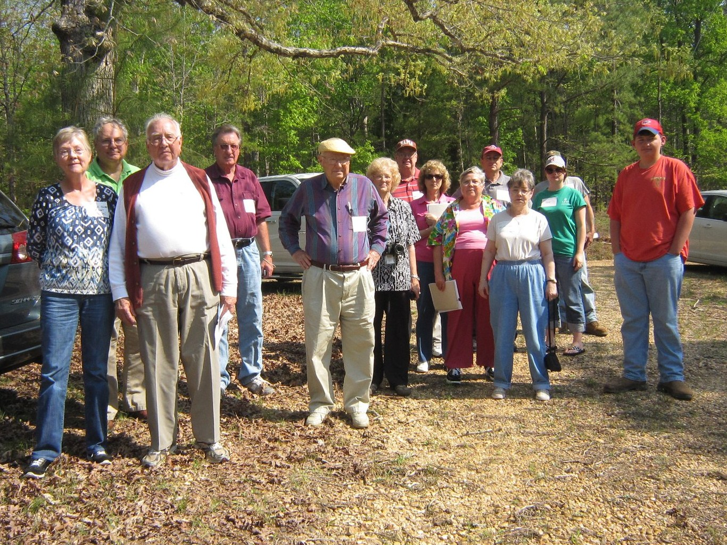

*All the above are either descendants of Charles (about 1795 - before 1850) or Cornelius Holliman (1792 - 1862).  Of course, all have the DNA of Christopher Holyman, Sr. (1618 - 1691), the Englishman who left Bedford, Bedfordshire and immigrated to Jamestown, Virginia in 1650.*

[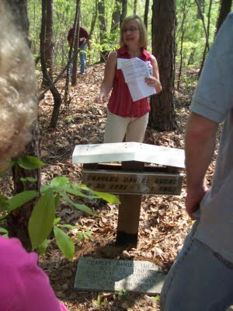](http://1.bp.blogspot.com/-RexvMRB41mc/Tamj-5-Cq9I/AAAAAAAACO0/nR_qP5IGInc/s1600/2011+4-9+Glenda+at+CDL+grave.JPG)

*Above, Glenda Norris shares information at the grave site of her 4th great grandfather, Charles Daniel Lucas Jr. whose daughter, Mary 'Polly' Lucas married Uriah Holliman, a son of Cornelius Holliman.  Below are her comments which she credits to Rhodes Holliman, her uncle.  It was Rhodes who, as a boy in the 1930s, would hike several miles into the piney woods, dodging a few snakes to re-discover the location for the family.  Several monuments now mark this spot.*

"Charles Daniel Lucas, Jr. was the son of Charles Daniel Lucas, Sr and “Dorcas” (no last name found), a possible Catawba Indian. Charles Jr. first saw life on June 30, 1771 and died May 31, 1853. He was a tailor by trade in South Carolina. Charles migrated to Alabama before the Holliman brothers from South Carolina arrived.  He earned his living 'stock dipping' and as a Creek Indian agent. He claimed to be ‘black dutch’, a term at the time to obscure one's possible Indian ancestry.

This burial site is in southern Fayette County, not far from Shepherd and Chapel Hill Baptist churches.  His grave is on a ridge line, over looking a ravine.  The site is an Indian burial ground as he chose to be buried with his friends. He was married to Mary Hasten. In spite of parenting 10 children, there was an estrangement in the family. Mary Hasten Lucas is buried at the Springhill Cemetery in the Bluff community, 20 or so miles north of this pioneer’s resting place.

Charles Jr. was a physical person.  Family tradition suggests strongly that Charles 'over disciplined, one of his son causing wife, Mary, to take her children and move to the other end of the county.  Another dramatic piece of family history records Charles killing a panther with  his knife and hands only!

When Charles Daniel Lucas was born, George III, was sovereign over the American colonies.  When Charles Jr. died Franklin Pierce had just become president of the United States, a union on the verge of dissolving."

*For additional information on Charles Daniel Lucas, Jr., go to Archives and the February 13 and 26, 2010 editions of this blog.****Rhodes Holliman****incorporated his own research and that of his father,****Cecil******Holliman****and the late****Walt Holliman****to create some excellent articles that are available for all to read.*

***More soon on both our Virginia Colonial past and the Holliman Migrations across the Southern United States from the 17th to the 19th Centuries....Information and your written insights always welcome as we share together.***